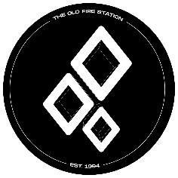

Event Set Up Form- The Old Fire Station

Please ensure you have completed the Event Proposal From prior to the event set up form. This form should be completed when the event has been agreed and a date has been set with The Old Fire Station
Deadlines:
All Event proposals must be received at least 4 weeks prior to your event date.
Please send completed forms with event artwork to jecclestone@bournemouth.ac.uk with the subject line Event Set Up – Society Name.
Website Listing Information
Society name:

Event Name:

Event date:
Event Timings:

Event Description (this is what customers will see as information about the event)
Music Genre
Ticket Price
(if multiple ticket releases please put price and quantity of tickets sold at this price)
Is this event student only? | Yes: No:

