
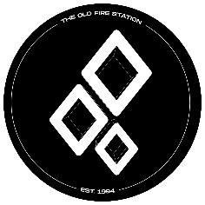
Event Set Up Form- The Old Fire Station

Please ensure you have completed the Event Proposal From prior to the event set up form. This form should be completed when the event has been agreed and a date has been set with The Old Fire Station
Deadlines:
All Event proposals must be received at least 4 weeks prior to your event date.
Please send completed forms with event artwork to info@oldfirestation.co.uk with the subject line Event Set Up – Society Name.
Website Listing Information

Society name:

Event Name:

Event Date:

Event Timings:

Full Event Description (this is what customers will see as information about the event)
Music Genre(s):

Ticket Price
(if multiple ticket releases please put price and quantity of tickets sold at this price)

THESE TICKETS WILL BE SOLD VIA THE OLD FIRE STATION WEBSITE
Is this event student only? | Yes: No:
Have you booked entertainment? (DJ’s / performers)
If so, what are their technical requirements?
The Old Fire Station will require event artwork for listing.
Please ensure you have this planned and send to email above.
info@oldfirestation.co.uk

