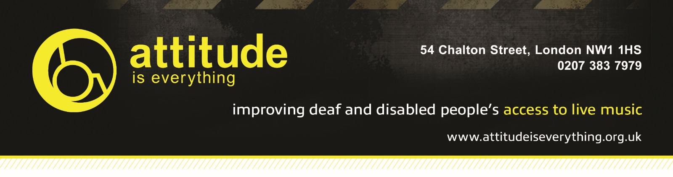

The Old Fire Station Access Info

- Introduction
The Old Fire Station is a multipurpose venue operated by the Students’ Union at Bournemouth University. We host club nights, live concerts, parties, comedy shows and similar style events open to the public and students.

We’re committed to making performances accessible as possible to everyone. We are offer free carers tickets for events at Old Fire Station to customers with disabilities. If the information you require is not listed below please ask us.

We follow advice from Attitude is Everything specifically to improve deaf and disabled people's access to live music by working in partnership with audiences, artists and the music industry. If you are interested in the work Attitude Is Everything does, then please visit their website to get involved or donate - www.attitudeiseverything.org.uk.

- Contact Details

Old Fire Station
36 Holdenhurst Road
Bournemouth
BH88AD
For enquiries please contact info@oldfirestation.co.uk
You can also call 01202 963039, however this number is not regularly staffed
Facebook Messenger https://www.facebook.com/subu.TOFS
Website www.oldfirestation.co.uk

- Download Link (word doc)
If you’d like to download this guide, please click: HERE

- Venue Description
There is step free access from the car park and other drop off points to the venue box office. There is step free access from the box office into the venue. Once inside the venue, there is step free access to all facilities, including toilets, cloakroom and the bar. The venue is split over two floors for some events and there is a lift.

Inside the venue, there are some raised areas which are accessible by ramps. Some of these raised areas provide better viewing opportunities for the stage and other areas.

The stage has no wheelchair access. There is no dedicated viewing platform or area.
- Bookable Free Personal Assistant Access & How To Apply

Deaf and disabled customers, who would be unable to attend a gig without assistance, are entitled to free event access for their ‘Personal Assistant’.
Please purchase one standard ticket. Once you have purchased a ticket, you should then contact us (see contact section) with your booking reference and name. We will then arrange and confirm your free access pass to be used by your 'Personal Assistant'.

Please note that our staff are not trained to lift or carry people who may need help or to assist with personal or medical needs. We provide a free personal assistant access in order that customers with these needs may be able to attend.
- Travel Guide
There is parking adjacent to the venue in Cotlands Road. There is also street parking directly in front of the venue on Holdenhurst Road.
The nearest National Rail Station is Bournemouth. On foot it is a 650m walk to the venue, ramped through an underpass.
There are multiple main route bus stops within 100m of the venue on Holdenhurst Road.

Taxi ranks are within 150m of the venue on Holdenhurst Road and Cotlands Road.

- Arrival Guide
On the evening of an event, we offer for disabled customers to arrive at the venue 10-15 minutes prior to the doors opening to allow for early entrance. The doors opening time can vary per event, so please check in advance. Please ask at the Box Office or Security Staff upon arrival. If you have a chair that needs storing or require a toilet key, please ask at this point too.
- Toilets
There are 3 sets of male, female and 2 gender neutral accessible toilets in the venue. The accessible toilets all require a radar key for access, please ask on arrival if you need a key.

Ground floor male and female toilets are located by the bar and doors in the main room, the accessible toilet is access through the ‘Engine Room’ door with the toilet sign above it. First floor male and female toilets are located off the dancefloor and the red stair case foyer, the accessible toilet is in the foyer of the blue staircase.
- Customers with Medical Requirements
We welcome attendees to bring medicine, food or drink needed to manage a medical condition as well as medical equipment with them to our venue. We do ask that you let staff know of any medicine, equipment or needed food and drink that is on your person upon arrival. In the event of an emergency, please contact security or ask to speak to the Duty Manager on shift.

- Access to Performance
At present the Old Fire Station does not have an induction loop or infra-red hearing assistance system fitted.

- Assistance Dogs
Registered (with Assistance Dogs UK) assistance dogs are welcome, please to let us know when you book if possible.

- Strobe Lighting
Strobe lighting, lighting that produces stroboscopic effects, smoke machines and other theatrical effects may be used during shows in our venue.

- Other Info
The bars in the venue are not currently lowered.

