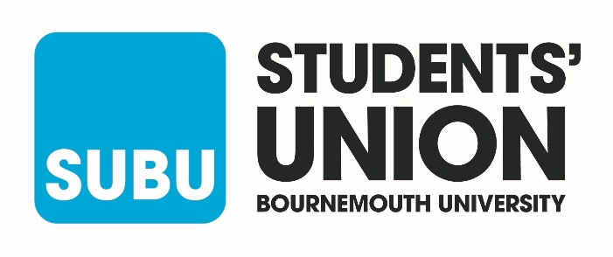
SUBU, we are committed to equal opportunities and dignity at work. We want to see this reflected not only in our work, but also in our staff.
In order for us to build and maintain an inclusive culture that represents all communities and identities, we ask anyone applying for a role to complete this form. It helps us track how well we’re doing at attracting, recruiting, and retaining people from different backgrounds.
We know how important data security is, and we will only use this information for monitoring and reporting. Any information you share will be stored securely and our reporting will ensure you are not be personally identifiable.
Please return completed form to subuhradmin@bournemouth.ac.uk
_______________________________________________________________________________________
1. Gender
Which of the following best describes your gender?
Man
Non-binary
Woman tick
Prefer not to say
If you describe your gender with another term, please provide this here:

2. Trans identity
Are you trans or do you have a trans history?
Yes
No tick
Prefer not to say

3. Sexual orientation
Which of the following best describes your sexual orientation? (Please feel free to select more than one if more than one applies to you)
Ace (including asexual, greysexual, demisexual)
Bi
Gay or lesbian
Heterosexual/straight tick
Prefer not to say
If you describe your sexual orientation with another term, please provide this here:

4. Romantic orientation
Which of the following best describes your romantic orientation? (Please feel free to select more than one if more than one applies to you)
Aro (including aromantic, greyromantic, demiromantic)
Bi
Gay or lesbian
Heterosexual/straight tick
Prefer not to say
If you describe your romantic orientation with another term, please provide this here:

5. Ethnicity
What is your ethnic group?
Arab
Asian or Asian British: Bangladeshi
Asian or Asian British: Chinese
Asian or Asian British: Indian tick
Asian or Asian British: Pakistani
Black or Black British: African
Black or Black British: Caribbean
Mixed: White & Black African
Mixed: White & Black Caribbean
Mixed: White & Asian
White: British
White: Irish
White: Roma
White: Other

Prefer not to say

If you would prefer to use your own term, please provide this here:

6. Religion and belief
What is your religion?
Buddhist
Catholic
Christian
Hindu
Jewish
Muslim tick
Non-religious (Atheist, Humanist etc)
Sikh
Prefer not to say
If you prefer to use your own term, please provide this here:

7. Disability
Do you consider yourself to be disabled?
Yes
No tick
Prefer not to say

8. Age
What is your age?
16-24 tick
25-34
35-44
45-54
55-65
65+
Prefer not to say

Thank you for taking the time to complete this form. Please return it with your application. We remove personal details from all applicants to avoid any bias and this information is not passed to the recruitment panel.

